Final Project Proposal Naveen K

3-7-18

Idea 1

Render a moving car

My idea is to render a modern car, and make it move. It will move forwards, right,left, and backwards. The wheels will also rotate as the car moves. My goal is to try to render a Tesla or a Toyota Camry is possible.

I have been looking at examples: This one is for a Chevy Camaro

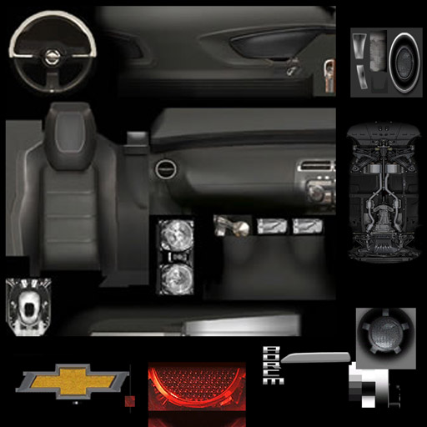

After inspecting the page source of the example I looked up, I discovered that this image was used. However, I am not sure how it is being used. I also am not sure how the exterior of the car was drawn as well as the interior.

Proposed time frame

Week 1

* Figure out which final project will be done, and research how to render a car

Week 2

* Collect images for the car. Begin coding the car in JS. Ask for help from teacher or students when possible

Week 3

* Begin to code the motion of the car, and the wheels to make them move

Week 4

* Add texture to the car, as well as correct any other issues from previous steps

Week 5

* Fancify car if possible

Implementation

* Will most likely use Three.JS. It will be a web based application